**Q1 Create database**

1. COLLEGE DATABASE:

STUDENT (USN, SName, Address, Phone, Gender)

SEMSEC (SSID, Sem, Sec)

CLASS (USN, SSID) SUBJECT (Subcode, Title, Sem, Credits)

IAMARKS (USN, Subcode, SSID, Test1, Test2, Test3, FinalIA)



**Use Database**



**Create table -1 Student**

CREATE TABLE student(

    SSN int NOT NULL PRIMARY KEY,

    SName VARCHAR(50),

    Address VARCHAR(250),

    Phone BIGINT,

    Gender CHAR(10),

);

**Insert values**

INSERT into student VALUES (1,"Shehbaz","Hauz Khas, New Delhi, Delhi",9524324356,"M");

INSERT into student VALUES (2,"Salman","khajuri Khas, New Delhi, Delhi",9524324356,"M");

INSERT into student VALUES (3,"Suman","Cyber city Khas, New Delhi, Delhi",9524324356,"F");

INSERT into student VALUES (4,"Puneet kumar", "Bi-pass old ring, New Delhi",9524324356,"M");

INSERT into student VALUES (5,"Hardeep Singh", "Hauz Khas, New Delhi, Delhi",9524324356,"M");

INSERT into student VALUES (6,"Ajay kumar varma","Hauz Khas, New Delhi, Delhi",9524324356,"M");

SELECT * FROM student;

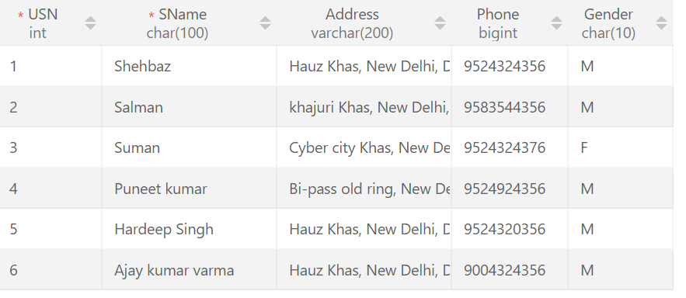

**Create table-2 SEMSEC**

create table semsec(SSID int,Sem VARCHAR(10),Sec CHAR(5));

INSERT into semsec VALUES(101,"2nd","A");

INSERT into semsec VALUES(102,"3nd","B");

INSERT into semsec VALUES(103,"1nd","A");

INSERT into semsec VALUES(104,"2nd","C");

INSERT into semsec VALUES(105,"1nd","C");

SELECT *FROM semsec;

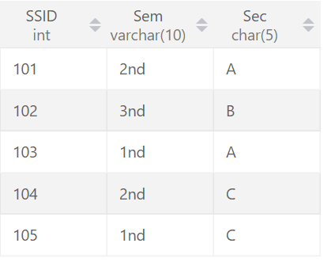

**Create table - 3 CLASS**

CREATE Table CLASS(USN int,SSID int);

INSERT INTO CLASS VALUES(1,101);

INSERT INTO CLASS VALUES(2,102);

INSERT INTO CLASS VALUES(3,103);

INSERT INTO CLASS VALUES(4,104);

INSERT INTO CLASS VALUES(5,105);

SELECT * FROM CLASS;

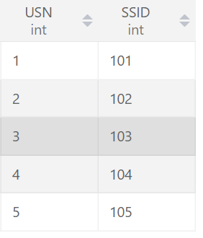

**Create table – 4 Subject**

CREATE TABLE subject(Subcode BIGINT,Title VARCHAR(88),Sem VARCHAR(20),Credits int);

INSERT INTO subject VALUES(201,"Accounting","2nd",4);

INSERT INTO subject VALUES(202,"Art","2nd",2);

INSERT INTO subject VALUES(203,"Accounting","2nd",4);

INSERT INTO subject VALUES(204,"Science","2nd",3);

INSERT INTO subject VALUES(205,"Accounting","2nd",2);

INSERT INTO subject VALUES(206,"Accounting","2nd",4);

SELECT *from subject;

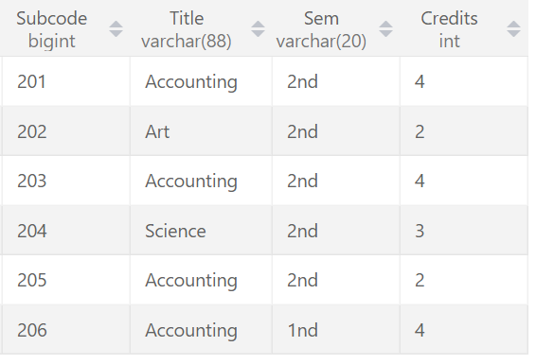

**Create table - 5 IAMARKS**

CREATE TABLE IAMARKS(USN int,Subcode BIGINT,SSID int,Test1 int,test2 int,Test3 int, FinallA BIGINT);

INSERT into iamarks VALUES(1,201,101,99,99,99,297);

INSERT into iamarks VALUES(2,202,102,98,99,99,296);

INSERT into iamarks VALUES(3,203,103,92,90,99,281);

INSERT into iamarks VALUES(4,204,104,98,96,95,289);

INSERT into iamarks VALUES(5,205,105,94,93,98,285);

SELECT * from IAMARKS;

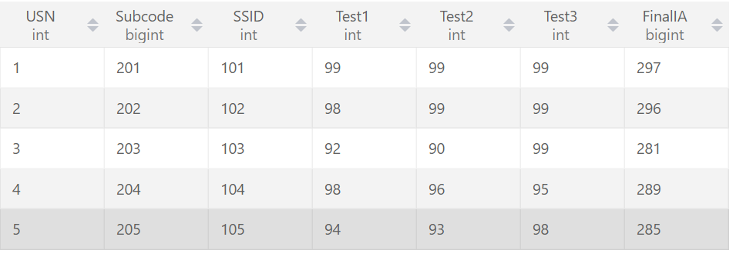

**2.COMPANY DATABASE:**

EMPLOYEE (SSN, Name, Address, Sex, Salary, SuperSSN, DNo)

DEPARTMENT (DNo, DName, MgrSSN, MgrStartDate)

DLOCATION (DNo,DLoc)

PROJECT (PNo, PName, PLocation, DNo)

WORKS_ON (SSN, PNo, Hours)

Create database Company ;

**Use Database**

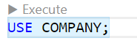

**Create table - 1 Employee**

CREATE TABLE EMPLOYEE(

    SSN int NOT NULL PRIMARY KEY ,

    Name VARCHAR(50),

    Address VARCHAR(250),

    Sex CHAR(10),

    Salary BIGINT,

    SuperSSN INT,

    DNO INT

);

**Insert values in Employee table**

INSERT into employee VALUES(1,"Shehbaz","Trilok Puri Delhi pin -110091","M",150000,101,201);

INSERT into employee VALUES(2,"Puneet","lok Puri Delhi pin -110091","M",140000,102,202);

INSERT into employee VALUES(3,"Aman Sharma","Trilok court Delhi pin -110091","M",140000,103,203);

INSERT into employee VALUES(4,"Suman","Trilok Pune Delhi pin -110091","F",154000,104,204);

INSERT into employee VALUES(5,"Sunil"," Camp, Khadki, and Dehu Road, Pune","M",155000,105,205);

INSERT into employee VALUES(6,"bhavya","Khadki, and Dehu Road, Pune","F",150600,106,206);

SELECT * FROM employee;

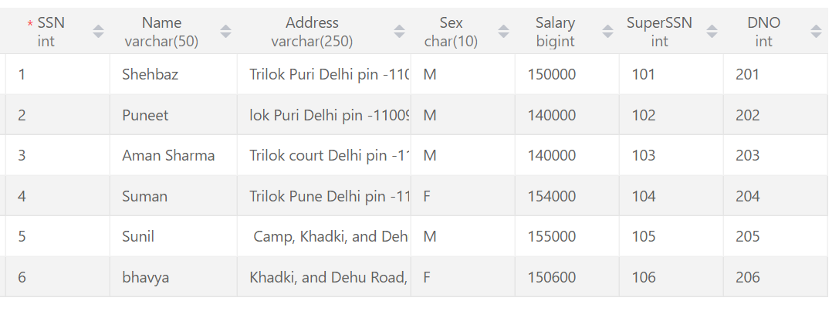

**Create table – 2 Department and Insert values**

CREATE Table DEPARTMENT(DNO INT,DName VARCHAR(60),MgrSSN BIGINT,MgrStartDate DATE);

INSERT into department VALUES(201,"Shehbaz",101,"2016-02-20");

INSERT into department VALUES(202,"Satvik",102,"2022-05-17");

INSERT into department VALUES(203,"Aman Sharma",103,"2016-06-16");

INSERT into department VALUES(204,"Puneet",104,"2015-09-19");

INSERT into department VALUES(205,"bhavya",105,"2021-02-22");

SELECT *from department;

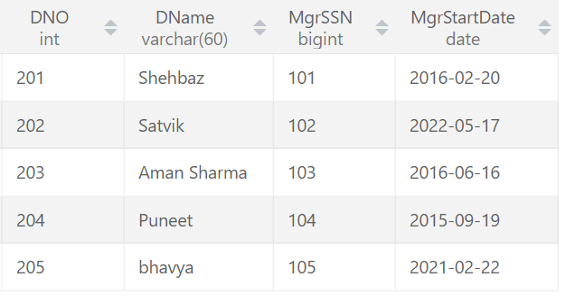

**Create table - 3 DLOCATION and Insert values**

use company;

CREATE TABLE DLOCATION(DNO int,DLoc int);

INSERT into DLOCATION VALUES(201,301);

INSERT into DLOCATION VALUES(202,302);

INSERT into DLOCATION VALUES(203,303);

INSERT into DLOCATION VALUES(204,304);

INSERT into DLOCATION VALUES(205,305);

SELECT *FROM dlocation;

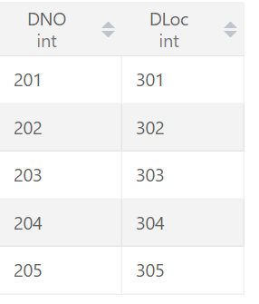

**Create table - 4 PROJECT and Insert values**

CREATE Table PROJECT(PNo int, PName VARCHAR(50), PLocation VARCHAR(60),DNO int);

INSERT into project values (1,"Ai Power", "Model Town",201);

INSERT into project values (2,"ML Power", "Mare Town",202);

INSERT into project values (3,"Ai human", "Kunal Town",203);

INSERT into project values (4,"Ai make New World", "Power Town",204);

INSERT into project values(5,"ML gives us new Power", "Our ML Town",205);

select *from PROJECT;

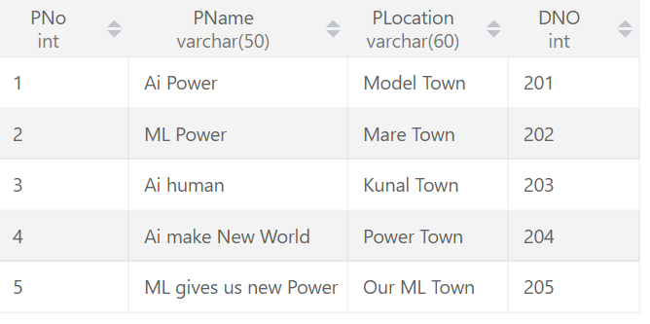

**Create table – 5 WORKS_ON and Insert values**

CREATE Table WORKS_ON(SSN INT,PNO int,Hours time);

desc WORKS_ON;

INSERT into WORKS_ON VALUES(1,1,'10:30:10');

INSERT into WORKS_ON VALUES(2,2,'12:30:10');

INSERT into WORKS_ON VALUES(3,3,'01:30:10');

INSERT into WORKS_ON VALUES(4,4,'09:30:10');

INSERT into WORKS_ON VALUES(5,5,'08:30:10');

SELECT * FROM WORKS_ON;

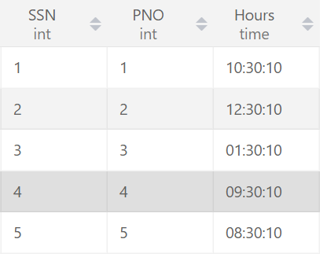

**Program 3:-**Write queries to execute following DDL commands :

1. CREATE :
2. ALTER:
3. DROP:

Create command query

CREATE DATABASE test;

use test;

CREATE table Student(id int, Name VARCHAR(40),Program VARCHAR(30),Enrolment_no BIGINT, Credit int);

desc Student;

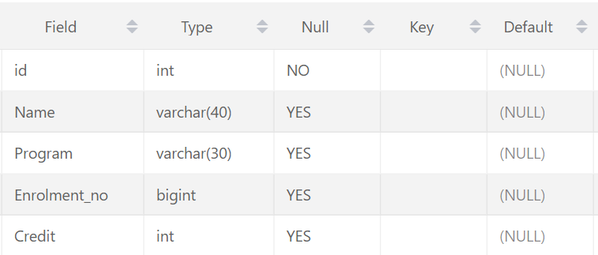

SELECT * FROM student;

INSERT into student VALUES(1,'Shehbaz','MCA',01917002021,4);

INSERT into student VALUES(2,'Akib','MCA',01916002021,3);

INSERT into student VALUES(3,'Satvik','BCA',01919002021,2);

INSERT into student VALUES(4,'Sarthak','MCA',01915002021,4);

INSERT into student VALUES(5,'Rahul Mittal','BCA',01921002021,3);

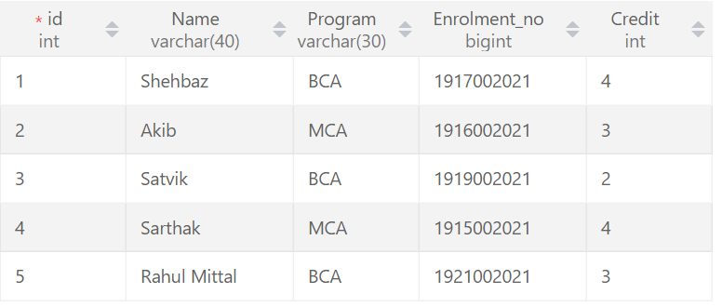

Q4 Alter command query

Change the size of a particular column.

alter TABLE student

MODIFY COLUMN Program char(50);



Add a new column to the existing table.

ALTER TABLE student

add COLUMN hello int;



Remove a column from the table.

Alter TABLE student

drop COLUMN hello;



DROP: Destroy the table along with its data.

drop TABLE student;

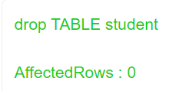

**Program 4:-**Write queries to execute following DML commands :

INSERT: Insert five records in each table.

UPDATE: Modify data in single and multiple columns in a table

DELETE: Delete selective and all records from a table.

Insert five records in table.

INSERT into student VALUES(1,'Shehbaz','MCA',01917002021,4);

INSERT into student VALUES(2,'Akib','MCA',01916002021,3);

INSERT into student VALUES(3,'Satvik','BCA',01919002021,2);

INSERT into student VALUES(4,'Sarthak','MCA',01915002021,4);

INSERT into student VALUES(5,'Rahul Mittal','BCA',01921002021,3);

Modify data in single and multiple columns in a table

UPDATE student set Program ="Btech" WHERE id = 1;



DELETE: Delete selective and all records from a table.

DELETE FROM student where id =3;

  
DELETE FROM student;

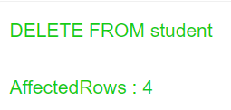

**Program 5:-**Write queries to execute following DML command :

SELECT: Retrieve the entire contents of the table.

Retrieve the selective contents (based on provided conditions) from a table.

Retrieve contents from a table based on various operators

i.e. string operators, logical operators and conditional operators, Boolean operators.

Sort the data in ascending and descending order in a table on the basis of one column or more than one column.

SELECT * FROM pin;

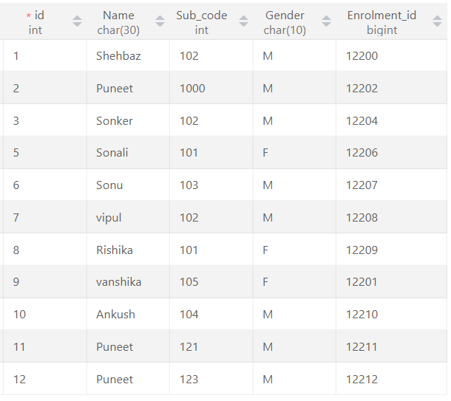

use hello;

SELECT *from best1;

-- String Operations

-- There are the two string operators:

--          Percent (%)  :  This Operator (%) matches any substring.

--          Underscore ( _ ) : This Operator ( _ ) matches any character.

-- String Operator

SELECT id, FName, Program FROM best1 WHERE FName LIKE 'Sh%';

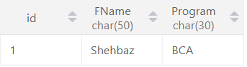

SELECT id, FName, Program, Department FROM best1 WHERE FName LIKE '_ha%';

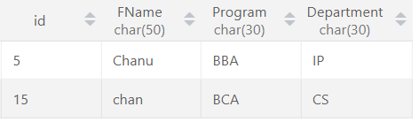

SELECT id, FName, Enrol_no FROM best1 WHERE FName LIKE 'Sal_%';

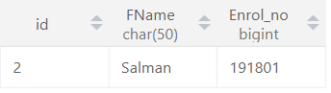

SELECT id, FName, Program, Dep_ID FROM best1 WHERE FName LIKE 'S__';

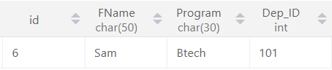

-- ......Logical Opreators........

-- .....also We can use And(&&),OR(||) NOT(!).....

SELECT * from pin;

SELECT * FROM pin WHERE id <= 3 AND Gender = "M";

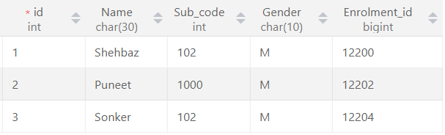

SELECT id, Name FROM pin WHERE id = 6 || id = 1;

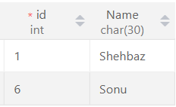

SELECT id, Name FROM pin WHERE  not(id = 6 OR id = 1);

SELECT id, Name FROM pin WHERE id  BETWEEN 5 AND 9;

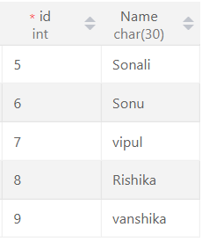

SELECT id, FName, Program FROM best1 WHERE Program IN('BCA' ,'BBA');

SELECT id, FName, Program FROM best1 WHERE FName LIKE 'S%';

SELECT id, FName, Program FROM best1 WHERE FName LIKE '_aa%';

SELECT * FROM best1 WHERE Program = ALL (SELECT Program FROM best1 WHERE Program = 'BCA');

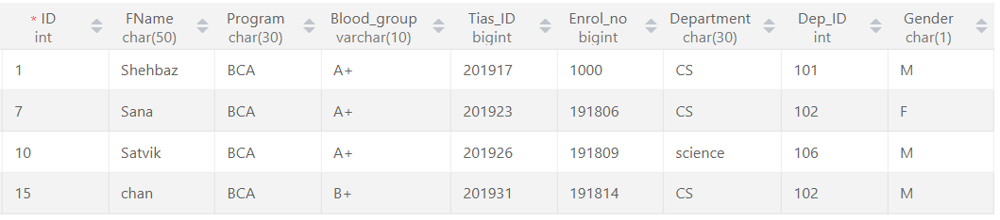

-- Arithmetic Operators ( + - * / % )

SELECT 40 + 20;

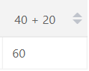

SELECT 40 - 20;

SELECT 40 * 20;

SELECT 40 / 20;

SELECT 40 % 21;

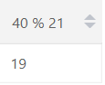

-- Comparision Operator < > >= <= !> <! == != ,.....,

SELECT * FROM pin ;

SELECT *FROM Pin where id >5;

SELECT *FROM Pin where id <5;

SELECT *FROM Pin where id >=5;

SELECT *FROM Pin where id <= 5;

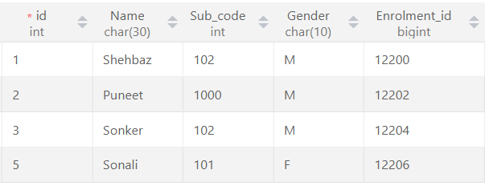

SELECT *FROM Pin where id != 5;

***Sort Table In Ascending Order by name basis of one column or more than one column.

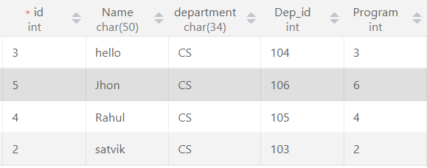SELECT *from best ORDER BY Name; SELECT *from best ORDER BY Name ,Program;   
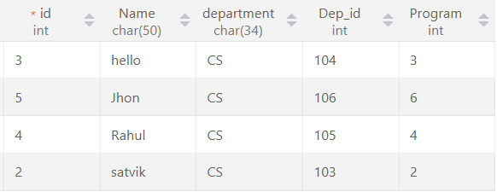

Sort Table In descending Order by name basis of one column or more than one column.

SELECT *from best ORDER BY Name DESC; SELECT *from best ORDER BY Name ,Program DESC;

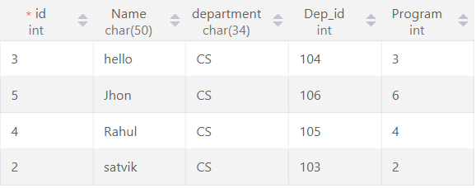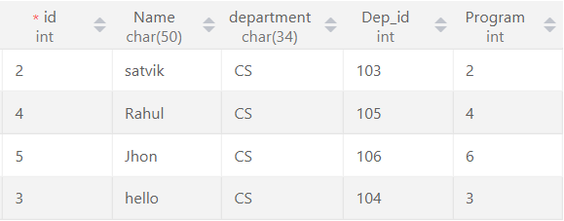

**Practical:-6** Create table using following integrity constraints:

1. Primary Key
2. Unique Key
3. Not Null
4. Check Default
5. Foreign Key

-- Child table for REFERENCES FOREIGN KEY;

CREATE TABLE City(

    ID INT ,

    City VARCHAR(160),

    PRIMARY KEY(ID)

    );

insert INTO city VALUES(1,"Agra");

insert INTO city VALUES(2,"Rohini");

insert INTO city VALUES(3,"Rithala");

insert INTO city VALUES(4,"Ankur vihar");

insert INTO city VALUES(5,"Kashmiri gate");

SELECT *from city;

ALTER TABLE city  RENAME  COLUMN  ID to C_ID;

-- /////////////////////////////////Main table

CREATE Table Personal(

    ID INT NOT NULL UNIQUE,

    Code_NO INT UNIQUE,

    FNAME VARCHAR(60) NOT NULL,

    Age INT NOT NULL check (Age >=18),

    Phone_no VARCHAR(10) UNIQUE,

    MyArea VARCHAR(80) NOT null DEFAULT 'Agra',

    City INT NOT NULL,

    PRIMARY KEY(ID),

    FOREIGN KEY (City)REFERENCES City(C_ID)

);

DESC Personal;

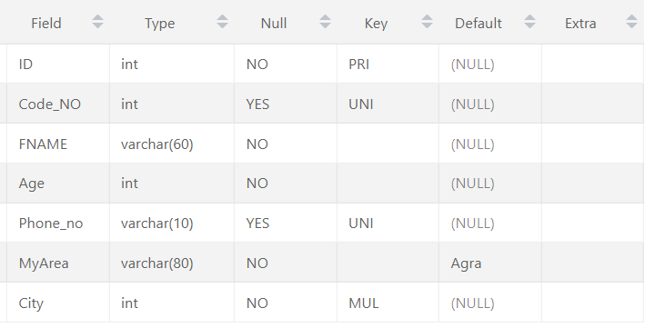

**Practical:-7** Write queries to execute following Aggregate functions Sum, Avg, Count, Minimum and Maximum value of a numeric column of a table using aggregate function.

SELECT *from best;

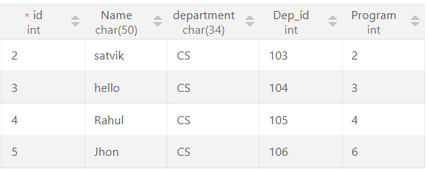

SELECT SUM(Dep_id) As Sum  FROM best;

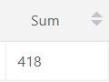

SELECT AVG(Dep_id) As Average  FROM best;

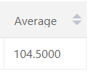

SELECT COUNT(Dep_id) FROM best;

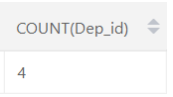

SELECT MAX(Dep_id) As Maximum  FROM best;

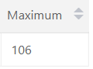

SELECT MIN(Dep_id) As Minimum  FROM best;

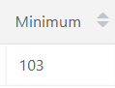

**Practical:-8** Retrieve data from a table using alias names .

**SELECT column as alias_name FROM table_name;**

**column:** fields in the table

**alias_name:** temporary alias name to be used in replacement of original column name

SELECT id as Stu_id, FName as Stu_Name, Program FROM best1 WHERE FName LIKE 'S%';

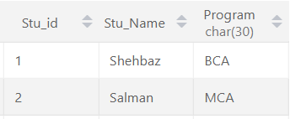

SELECT MIN(Dep_id) As Minimum  FROM best;

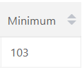

**Practical:- 9** Retrieve data of a table using nested queries.

SELECT * FROM best1 WHERE Program = ALL (SELECT Program FROM best1 WHERE Program = 'BCA');

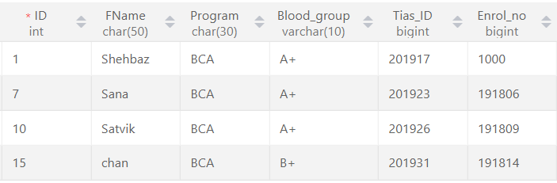

SELECT Name from pin WHERE id = ANY(SELECT id FROM best WHERE  Dep_id>103);

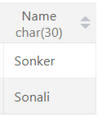

**Practical:-10** Retrieve data from more than one table using inner join, left outer, right outer and full outer joins

***INNER JOIN means intersection of two table

SELECT * from best INNER JOIN best1

ON best.Program = best1.ID;

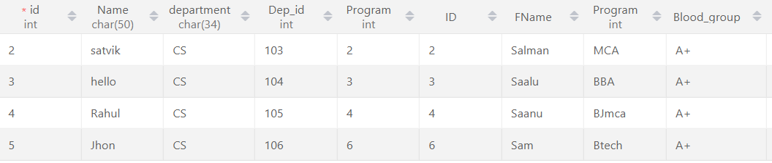

SELECT b.id,b1.FName,b.Name from best b INNER JOIN best1 b1

ON b.Program = b1.ID;

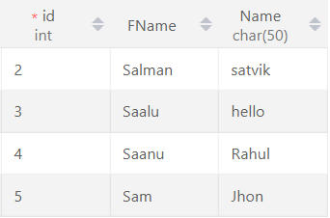

SELECT b.id,b.Name,b1.Program,b1.FName from best b INNER JOIN best1 b1

ON b.Program = b1.ID WHERE b1.Program = "BBA";

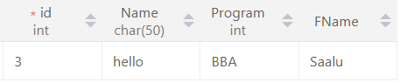

**\*\*\*\*The left join returns all records from the left table(t1), and the matched records from right table(t2)**

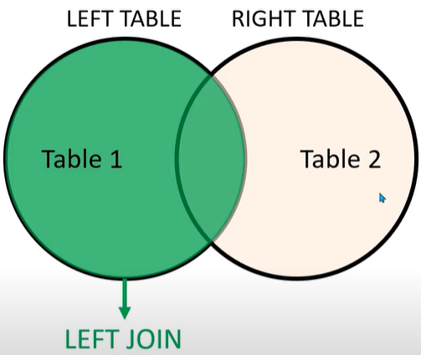

SELECT * FROM best LEFT JOIN best1 ON best.Program = best1.ID;

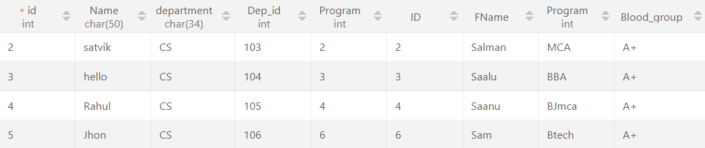

SELECT b.id,b.Name,b1.department,b1.ID,b1.Program FROM best b LEFT JOIN best1 b1 ON b.id = b1.ID ORDER BY Name ;

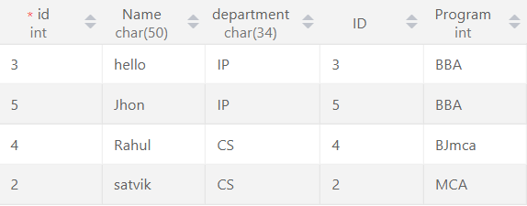

SELECT b.id,b.Name,b1.department,b1.ID,b1.Program FROM best b LEFT JOIN best1 b1

ON b.id = b1.ID WHERE b1.Program="MCA";

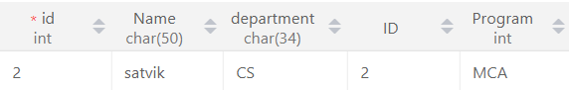

**\*\*\*\*The Right join returns all records from the right table(t2), and the matched records from left table(t1)**

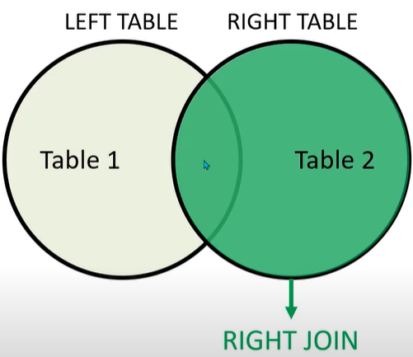

SELECT * FROM best RIGHT JOIN best1 ON best.Program = best1.ID;

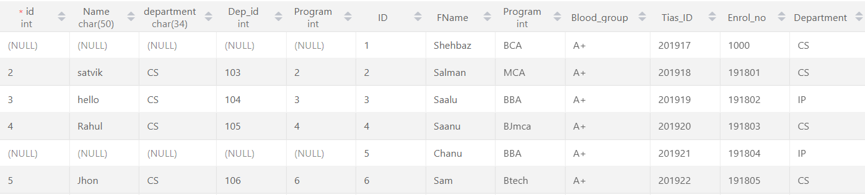

SELECT * FROM best1 b1 RIGHT JOIN best b ON b1.ID = b.id;

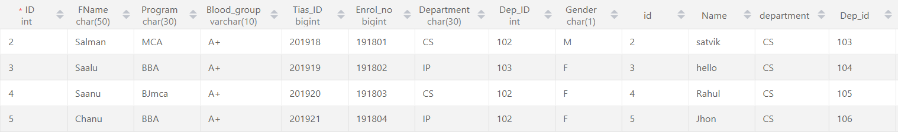

SELECT b.id,b.Name,b1.department,b1.ID,b1.Program FROM best1 b1 RIGHT JOIN best b

ON b1.ID = b.id WHERE b1.Program="Bjmca";

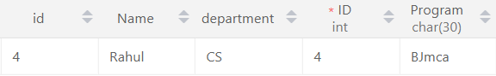

***Cross join means every 1 row of t1 repeat with respect to t2 ****

SELECT * FROM dept CROSS JOIN city;

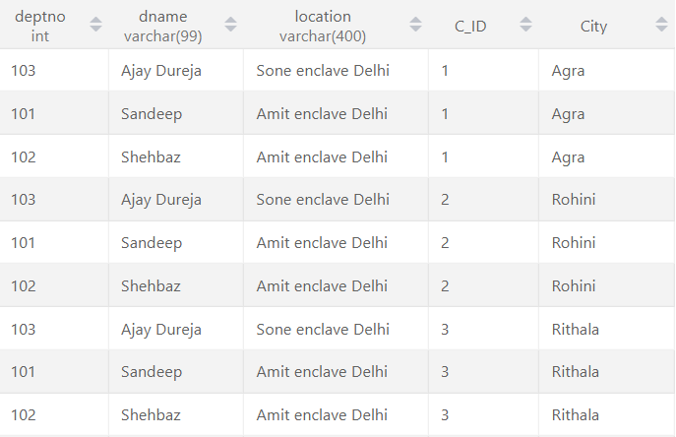

**Practical:- 11** Create view from one table and more than one table.

CREATE VIEW Stu_info as select Name, Dep_id FROM best ,Program_  WHERE  best.Program = program_.program_id;

SELECT * FROM stu_info;

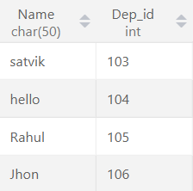

**Practical:- 12** Create index on a column of a table.

use hello;

SELECT * FROM best1;

create index index_Tias on best1(FName, Program, Tias_ID);

show index from best1;

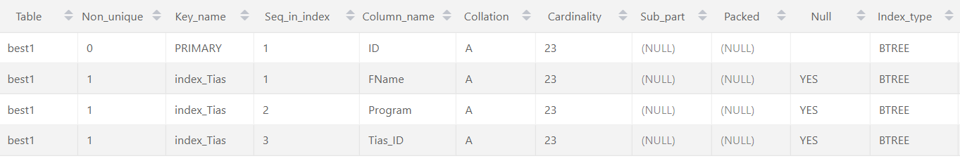

drop index index_Tias on best1;

**Practical:- 13** Consider the Insurance company’s Database given below.

The primary keys are underlined and the data typesare specified.

PERSON(driver_id# : string, name : string, address : string)

CAR(regno : string, model : string, year : int)

ACCIDENT(report_number : int, acc_date : date, location : string)

OWNS(driver_id# : string, regno : string)

PARTICIPATED(driver_id# : string, regno : string, report_number : int, damage_amount :number(10,2) )

1. Create the above tables by properly specified the primary key and the foreign key

(ii) Enter at least five tuples for each relation

1. Demonstrate how you can a. Update the damage amount for the car with a specific regno, the accident with report number 12 to 25000. b. Add a new accident to the database.
2. Find the total number of people who owned cars that were involved in accident in2002.

(iv) Find the number of accident in which cars belonging to a specific models were involved